Data Source: Employee_Data.csv

**Fields: id, first_name, last_name, gender, department, salary**

Problem Statement

**Write a program that would read the given data source and provide the user with custom reports**

**Must implement: Template and LinkedList concepts**

**Your program must meet the following requirements:**

1. **Create a menu with the following options**
2. **Display All**
3. **Exit**

**It should display the contents of the file, sorted in ascending order by id, and with the total salary at the end of the report. Don’t forget to replace Your Name with your name(s).**

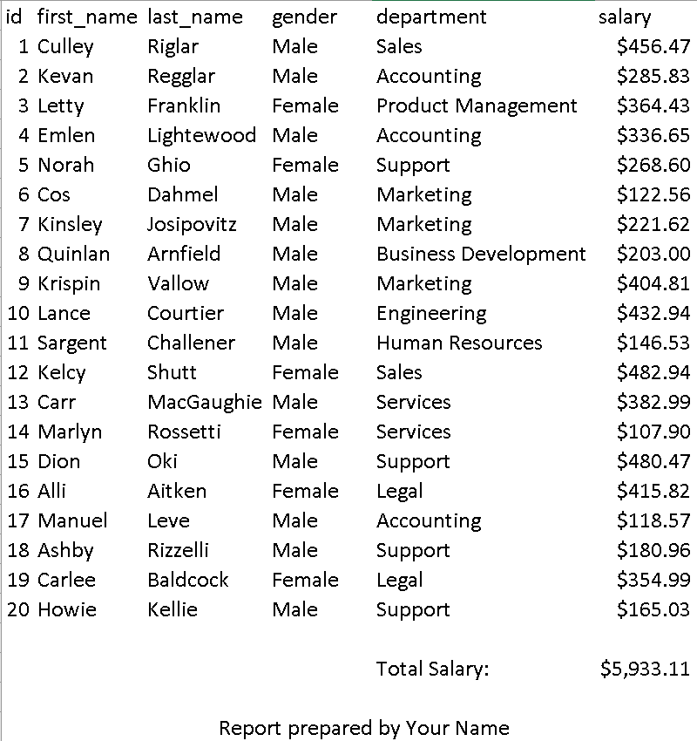

Submissions

1. **Submit your program to D2L in the Lab6 Folder**
2. **Filename: Lab6_group#.cpp**
3. **Must use function prototype whenever necessary.**
4. **Refrain from putting all the tasks in one function**
5. **Makefile**